CYB MDM 11.5 Workstation Setup

For Windows 7

Presented to: CYB

Prepared by: Rodney Spence (rodney@infotrellis.com), InfoTrellis

Table of Contents

[Document Scope 2](#_Toc460858353)

[Prerequisites 2](#_Toc460858354)

[Installation Files 2](#_Toc460858355)

[Stewardship Center 3](#_Toc460858356)

[Oracle SQL Developer Install 3](#_Toc460858357)

[Install MDM 4](#_Toc460858358)

[IBM Installation Manager 4](#_Toc460858359)

[WebSphere Setup 5](#_Toc460858360)

[Update JDK to 1.7 in WAS 8](#_Toc460858361)

[Profile Creation 11](#_Toc460858362)

[MDM Installation 16](#_Toc460858363)

[Install RAD with Workbench 31](#_Toc460858364)

[RAD configuration 31](#_Toc460858365)

[Enable Capabilities 31](#_Toc460858366)

[Modify WebSphere Server Runtime Environment 32](#_Toc460858367)

[Configure MDM Application Path 33](#_Toc460858368)

[Workspace preparation 33](#_Toc460858369)

[Add RAD Activation Key 38](#_Toc460858370)

# Document Scope

This documentation describes the setup of a MDM v11.5 Workstation for CYB using Windows 7 64-bit and Oracle.

# Prerequisites

|  |
| --- |
| IBM Installation Manager 1.8.4 |
| WebSphere Application Server v8.5.5.9 |
| Rational Application Developer v9.5 |
| MDM v11.5 |

# Installation Files

* Oracle SQL Developer
  + Software Center install
* IBM Installation Manager 1.8.4
  + agent.installer.win32.win32.x86\_64\_1.8.4000.20151125\_0201
* WebSphere Application Server v8.5.5
  + WAS\_V8.5.5\_1\_OF\_3.zip
  + WAS\_V8.5.5\_2\_OF\_3.zip
  + WAS\_V8.5.5\_3\_OF\_3.zip
* IBM Java SDK 1.7.1
  + 7.1.3.30-WS-IBMWASJAVA-Win
* WebSphere Fix Pack 9
  + 8.5.5-WS-WAS-FP0000009-part1
  + 8.5.5-WS-WAS-FP0000009-part2
* Rational Application Developer v9.5
  + RAD\_WS\_9.5\_1.zip
  + RAD\_WS\_9.5\_2.zip
* MDM Workbench v11.5.0.3
  + MDM\_STD\_ADV\_11.5\_ML\_1
  + MDM\_STD\_ADV\_11.5\_ML\_2
  + MDM\_STD\_ADV\_11.5\_ML\_3
  + MDM\_STD\_ADV\_11.5\_ML\_4
  + 11.5.0.3-MDM-WB-FP03IF000

# Stewardship Center

The Stewardship center is not part of the MDM development environment but, to reach the Stewardship Center use the following URL.

<https://vrhmdmt201:13019/ProcessPortal/>

# Oracle SQL Developer Install

This installation serves two purposes. It installs a data base client that will be used during MDM development. It also installs drivers needed for the rest of the installs in this document.

Open Software Center

Click on “Find additional applications from the Application Catalog”

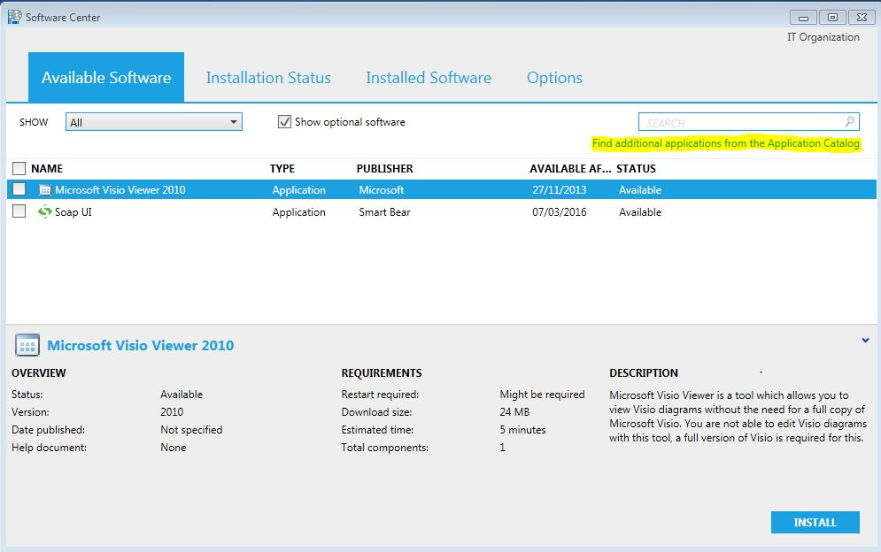

On the top right of the screen in the search window type the following: Oracle SQL Developer

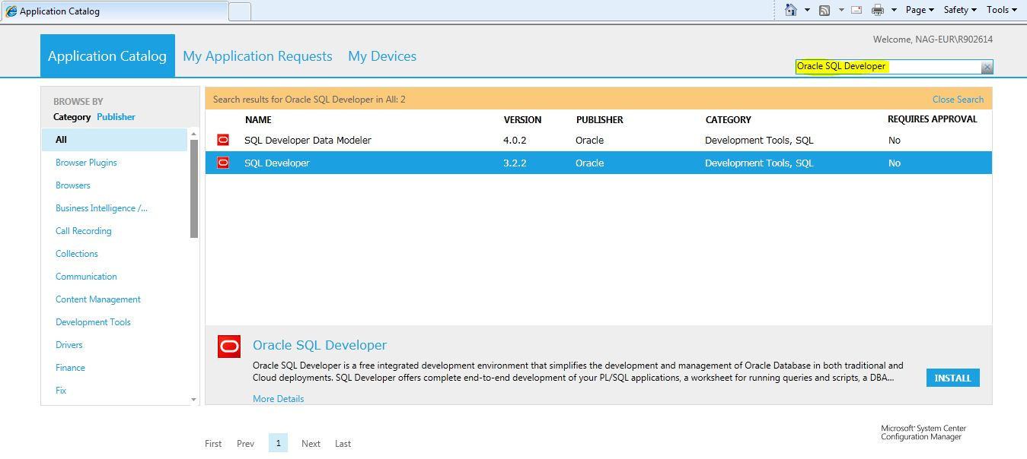

Select Oracle SQL Developer to install

Click Install.

Once installed, use the information sheet provided by the DBA to configure a connection to your development schema.

\*\*NOTE: The Oracle Database/Schema and Table Spaces will be created by a DBA. This request must be made in advance. When the DBA has completed the Schema creation they will provide the database details needed for later steps.

Create an ORACLE\_HOME environment variable set to “C:\Oracle\Ora11g”

Add “C:\Oracle\Ora11g\bin” to the path if it is not there already.

# Install MDM

## IBM Installation Manager

Retrieve and install the IBM Installation Manager from the IBM Fix Central website (http://www-01.ibm.com/support/docview.wss?uid=swg24040291) and always run it as administrator. Any version above 1.5 will be sufficient.

Extract all the installation files locally and add them to the Installation Manager’s repository.

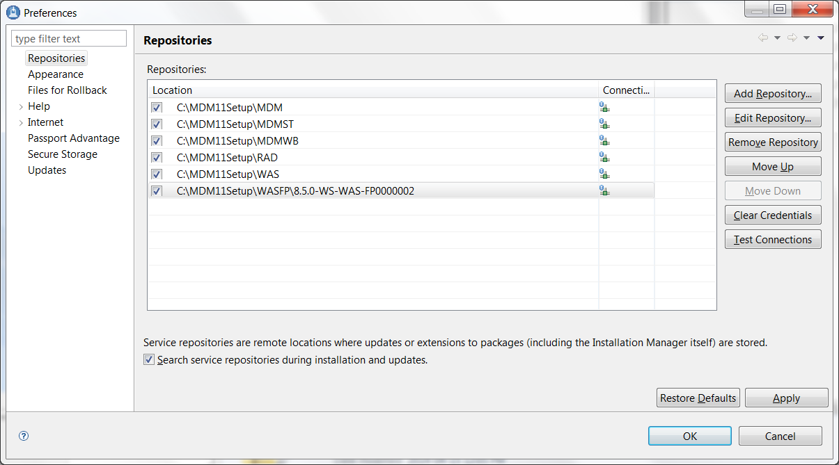

Figure 1 Repository List

## WebSphere Setup

Launch Installation Manager as Administrator, and select IBM WebSphere Application Server 8.5.5.9 to install.

**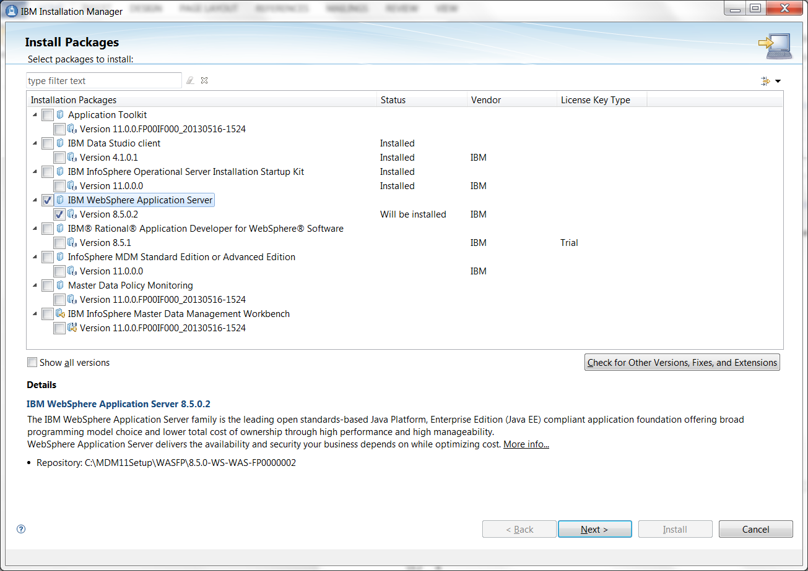**

Set the WAS server installation directory. This document will use “C:\IBM\WebSphere\AppServer” and will be referred to as **<WAS\_HOME>**.

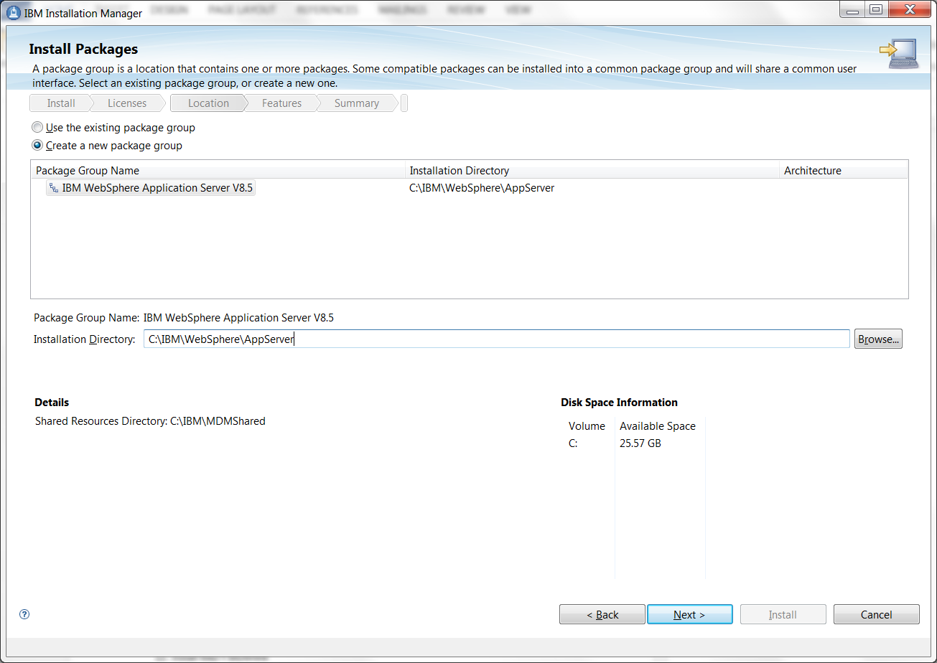

Select defaults for the installation until the end. **Choose none**. Running the Profile Management Tool will happen in a later step.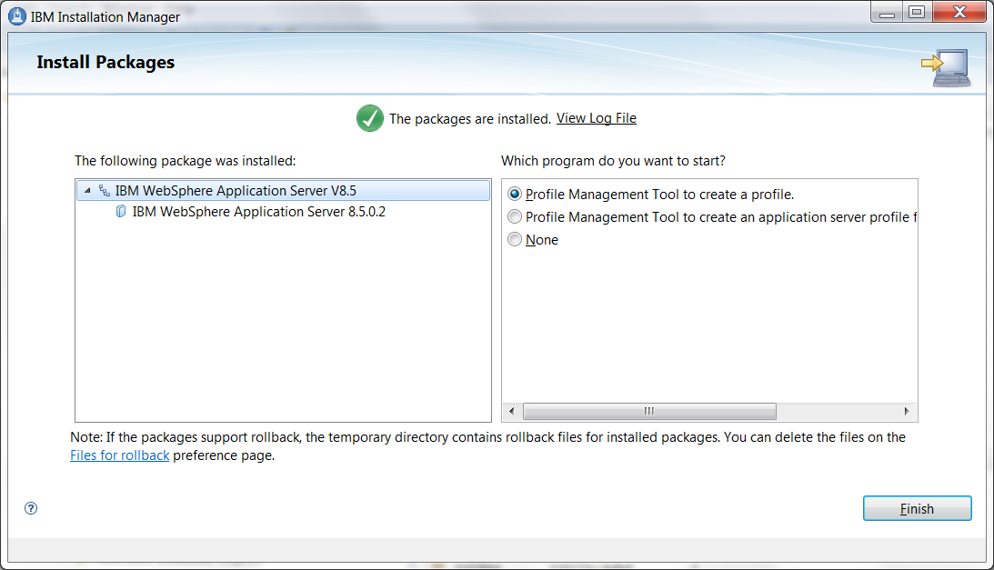

### Update JDK to 1.7 in WAS

Launch Installation Manager as Administrator, and select install.

Check IBM WebSphere SDK Java Technology Edition (Optional)

* Version 7.1.3.30

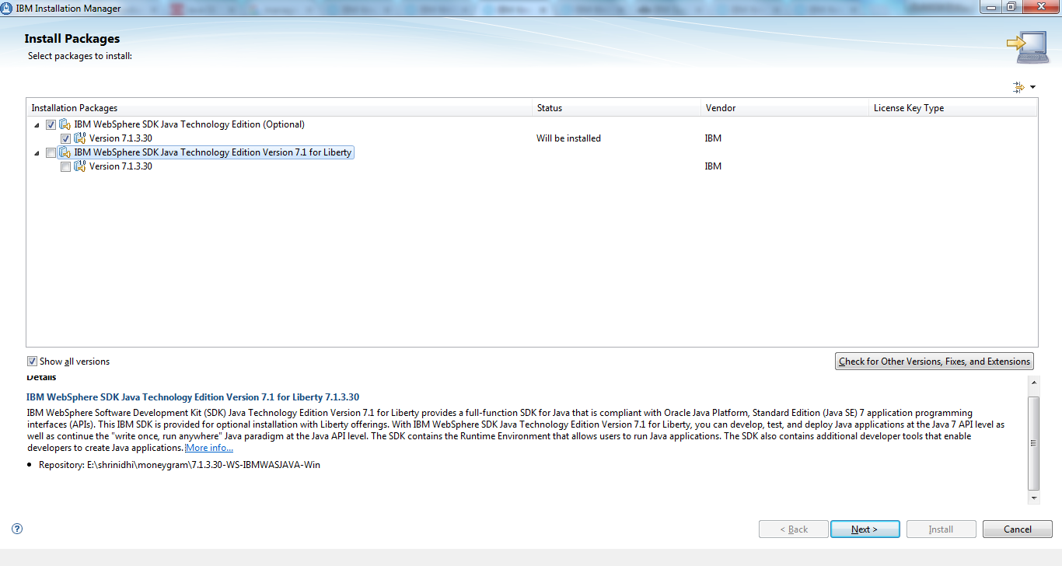

Select the IBM WebSphere Application Server V8.5 package group if not already selected by default

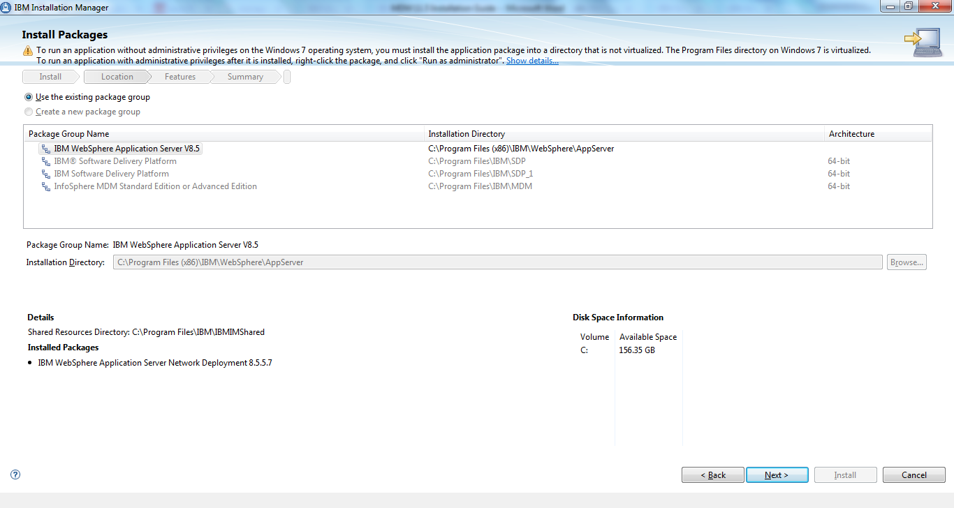

Click Install

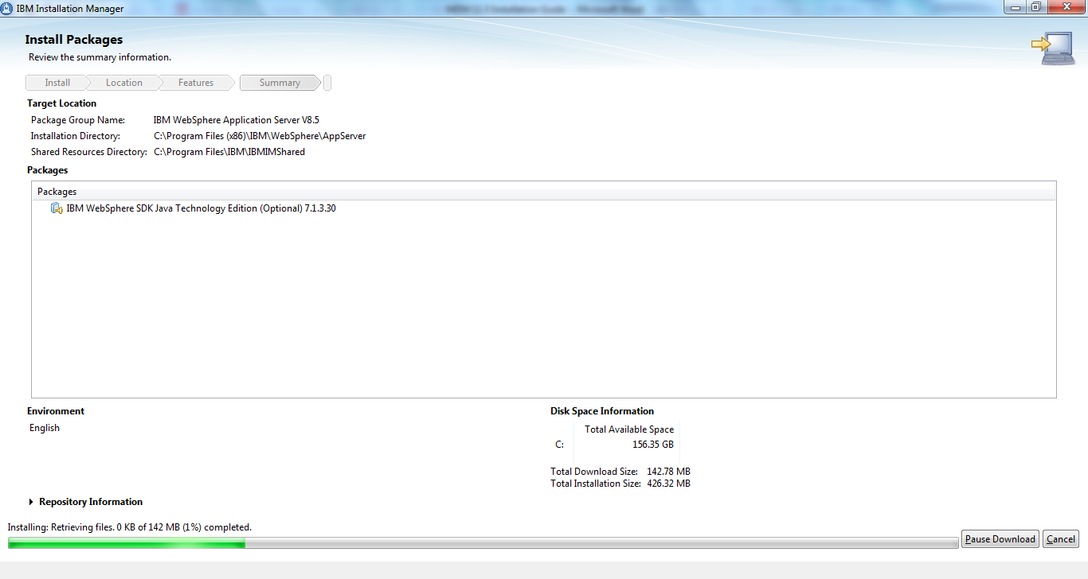

When the install completes click finish.

Once the SDK has been installed New Environment Variables need to be created as follows

Set JAVA\_HOME environment variable (This Environment Variable may need to be created)

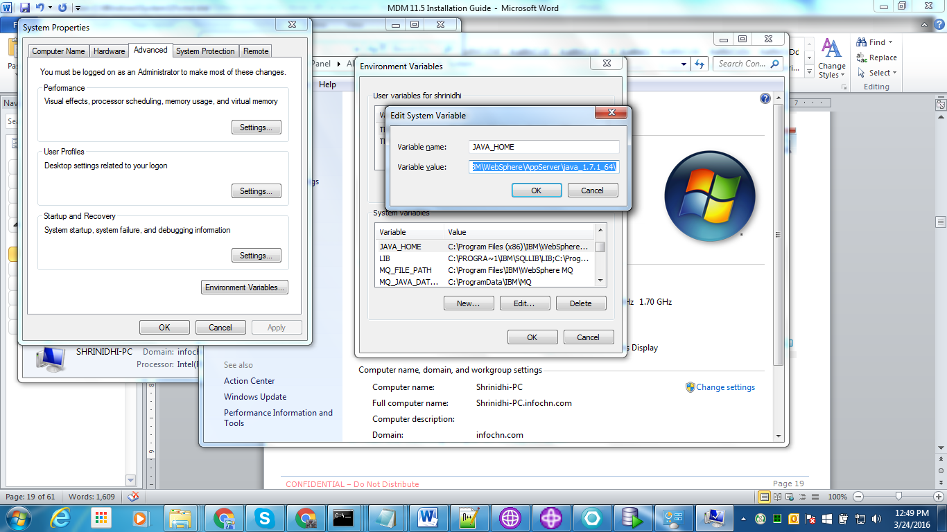

The JAVA\_HOME value should be C:\IBM\WebSphere\AppServer\java\_1.7.1\_64\ if you have used the documented directory otherwise <WAS\_HOME>\ java\_1.7.1\_64\

Set WAS\_HOME environment variable (This Environment Variable may need to be created)

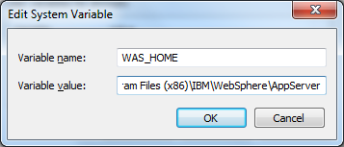

The WAS\_HOME value should be C:\IBM\WebSphere\AppServer if you have used the documented directories, otherwise, it will be the location of the AppServer directory under where the WebSphere Application Server was installed.

Open an Admin Command Window and Navigate to WAS\_HOME\bin and run the following two commands

* managesdk -setCommandDefault -sdkname 1.7.1\_64
* managesdk.bat -setNewProfileDefault -sdkname 1.7.1\_64

Launch the WAS admin console (Start the server if it has not already been started) and confirm that the Java SDK has been installed and is now the default SDK

In the admin console

* Select WebSphere application servers
* Select server1
* Select Java SDKs

You should see a screen similar to the one below with 1.7.1\_64 with default set to true.

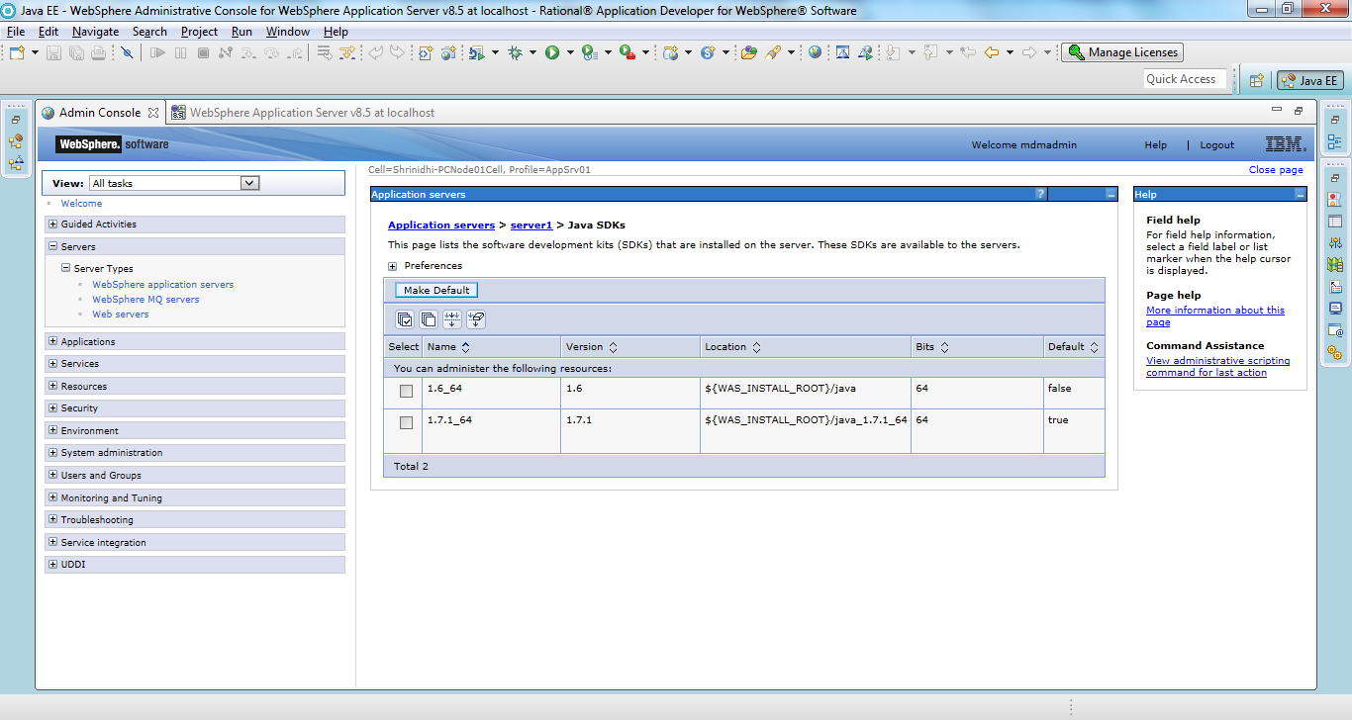

Increase Java Heap Size

* Select WebSphere application servers
* Select server1
* Under Java and Process Management select Process Definition
* Under Additional Properties select Java Virtual Machine
* Set the Initial heap size to 512 MB and the Maximum heap size to 1024 MB
* Click OK and save your changes to the Master Configuration

### Profile Creation

Run "D:\IBM\WebSphere\AppServer\bin\ProfileManagement\pmt.bat" or if your WAS\_HOME is different “<WAS\_HOME>\bin\ProfileManagement\pmt.bat"

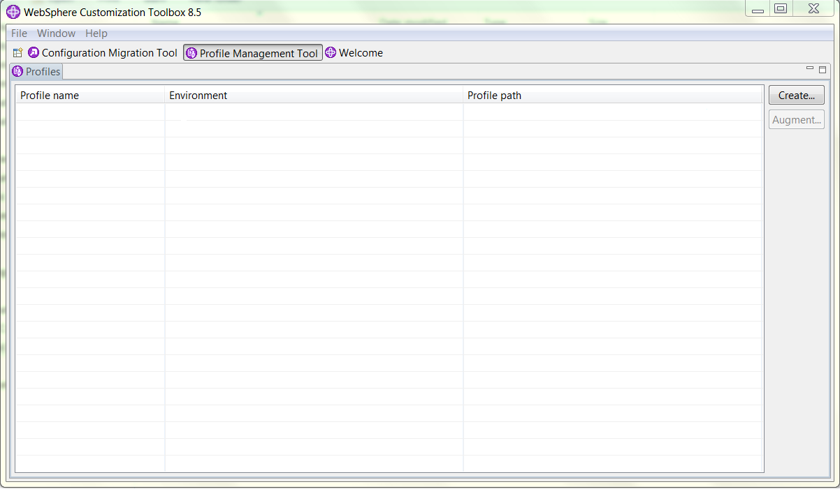

Select Create

Then Select “Application Server” in the list and click next

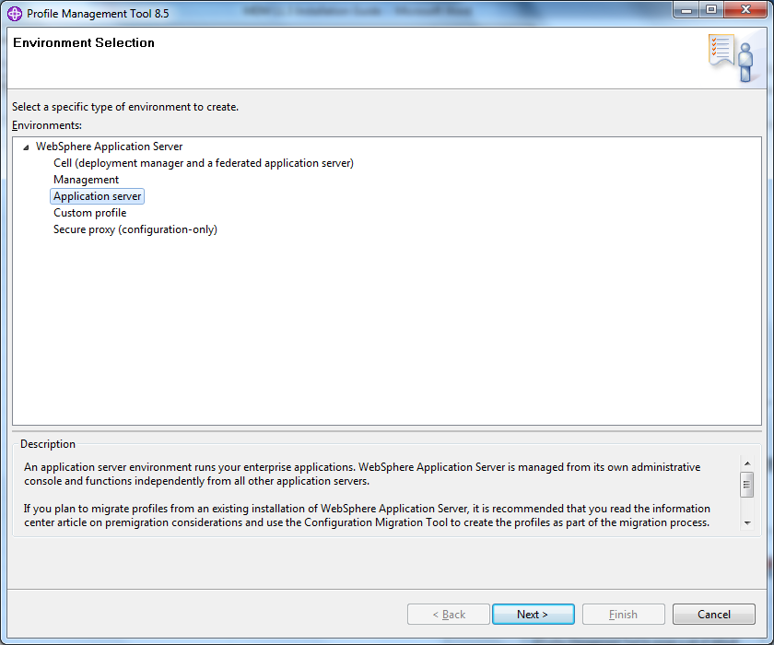

Create a Application Server. Select Advanced Profile Creation.

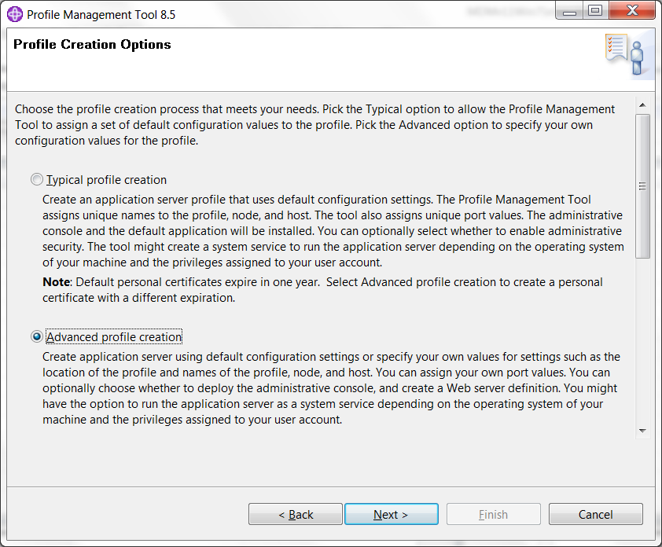

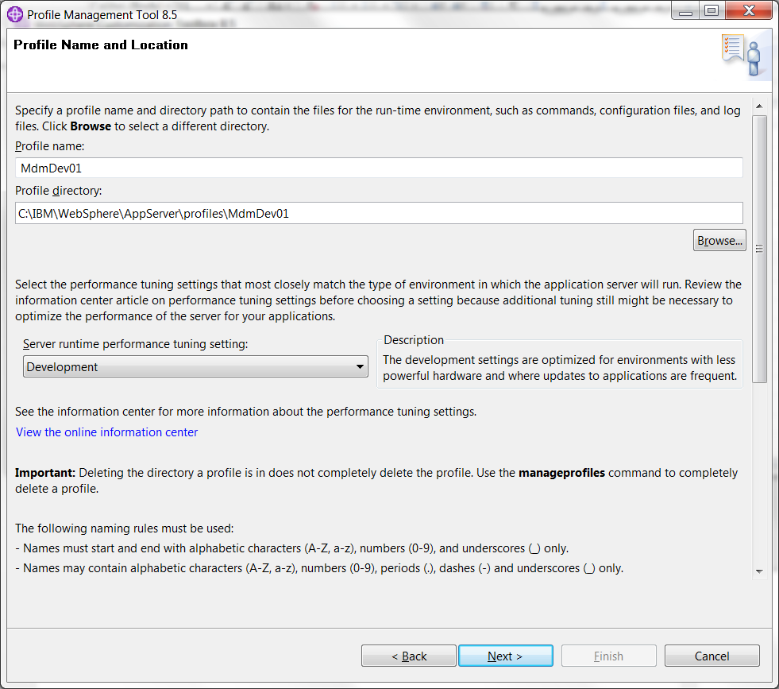

|  |  |
| --- | --- |
| Profile name: | MDMDev01 |
| Profile Directory: | <WAS\_HOME>\profiles\MDMDev01 |
| Server Runtime performance tuning setting: | Development |

Enable security and create a username and password for WebSphere.

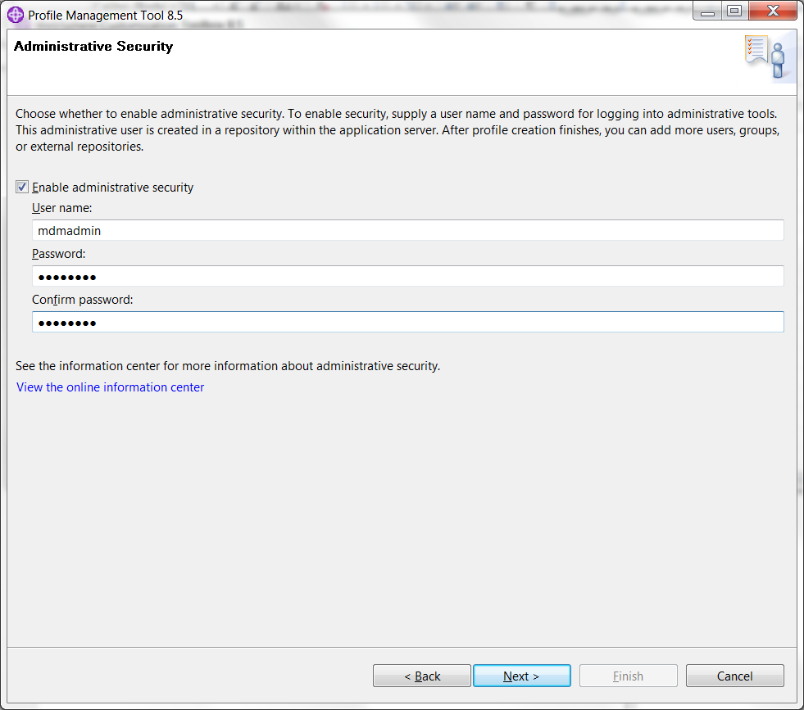This document will use mdmadmin as the username and password as the password. They will be referred to as **<WAS\_USER>, <WAS\_PASSWORD>**.

Uncheck “Run the application server process as a Windows Service”.

**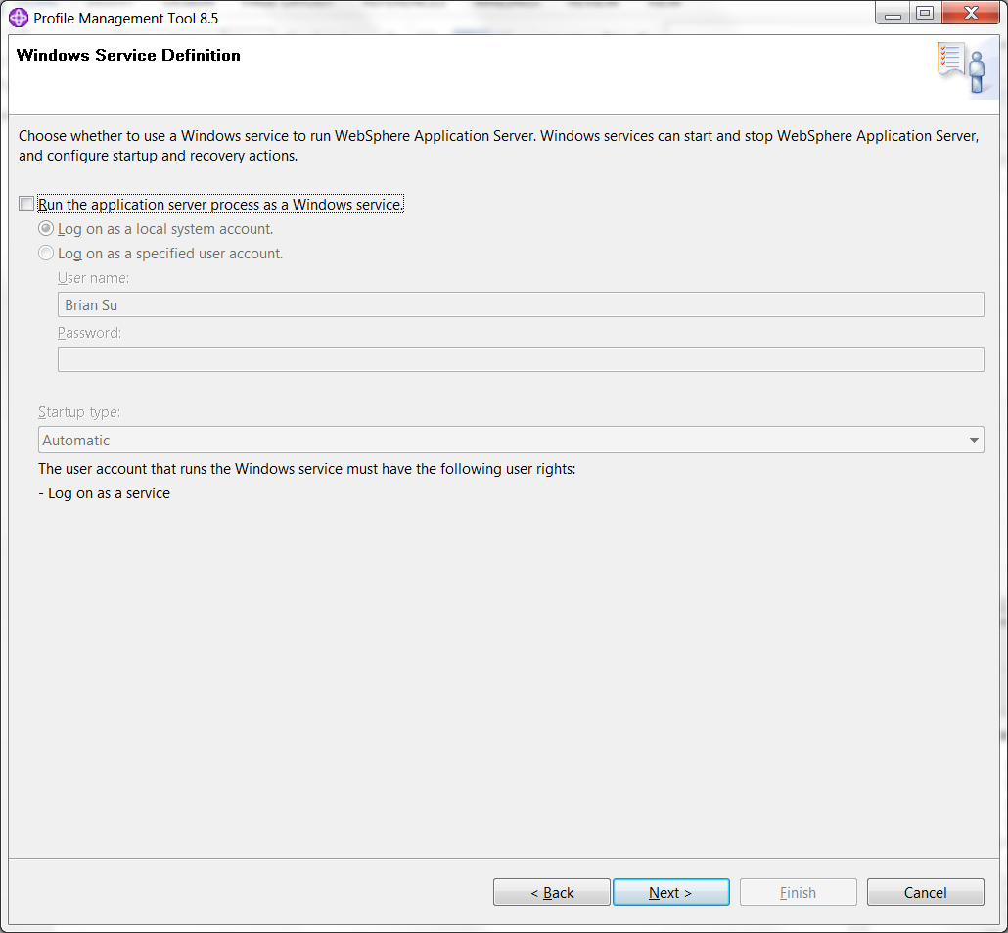**Create the profile.

Start the server and load up the websphere admin console with the path (eg. <https://localhost:9043/ibm/console/logon.jsp>)

Navigate to Environment 🡪 WebSphere Variables 🡪 ORACLE\_JDBC\_DRIVER\_PATH and it to the parent folder of **<ORACLE\_HOME>**.

Navigate to **<WEBSPHERE\_HOME>**\profiles\AppSrv01\properties and edit soap.client.props and set:

com.ibm.SOAP.requestTimeout=0

Restart the server.

## MDM Installation

Select “InfoSphere MDM Standard or Advanced Edition v11.5.0.0” in Installation Manager.

**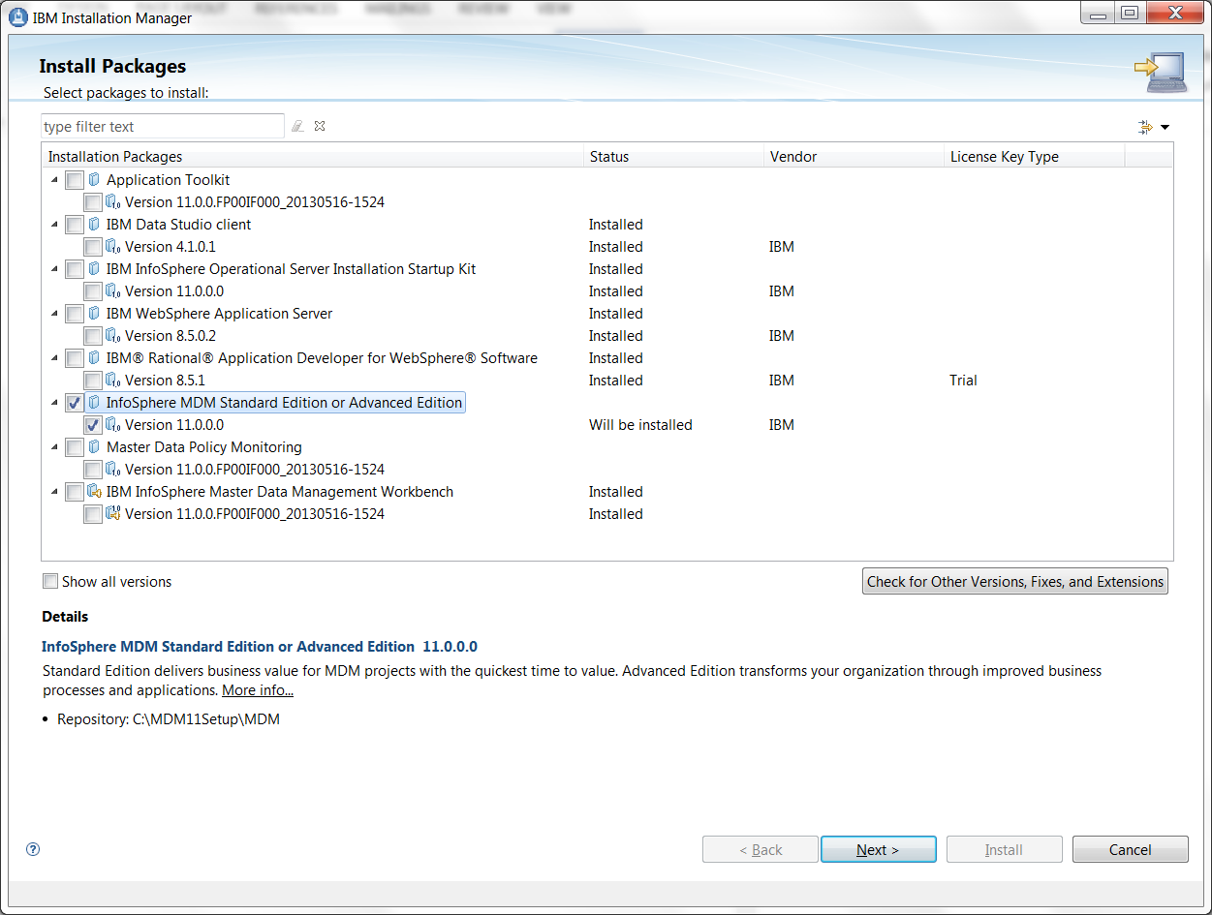**

Use “C:\IBM\MDM” as MDM home.**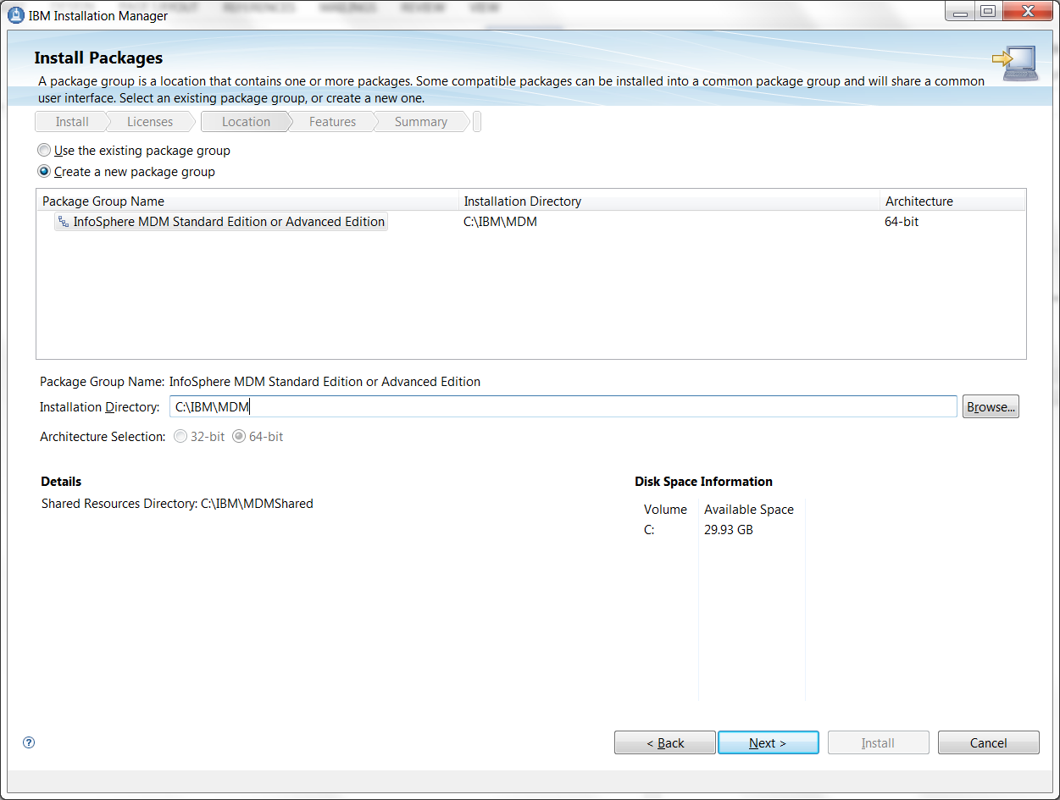**

Check “MDM Database” and “MDM Operational Server”.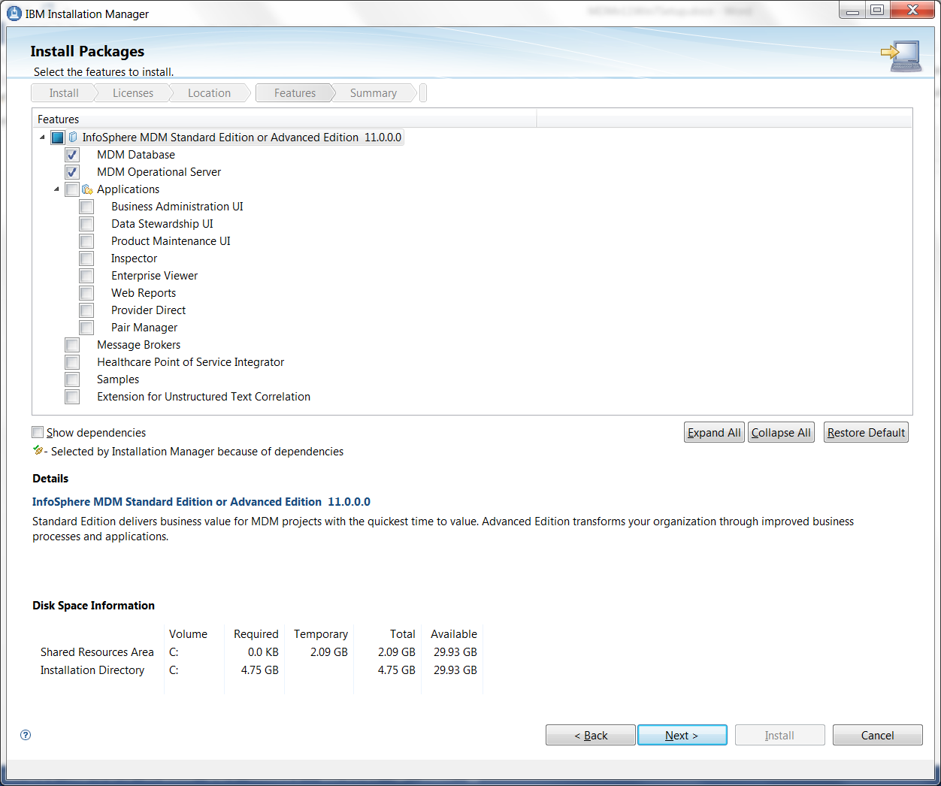

Fill out the fields of “Database Configuration” section with the table below. The User name and password should have been received from the DBA.

|  |  |
| --- | --- |
| Database Type: | Oracle |
| Database Hostname: | Use information provided by DBA |
| Database Port: | Use information provided by DBA |
| Database user name: | Use information provided by DBA |
| Database password: | Use information provided by DBA |
| Database Name: | Use information provided by DBA |
| Database home: | C:\Oracle\Ora11g |

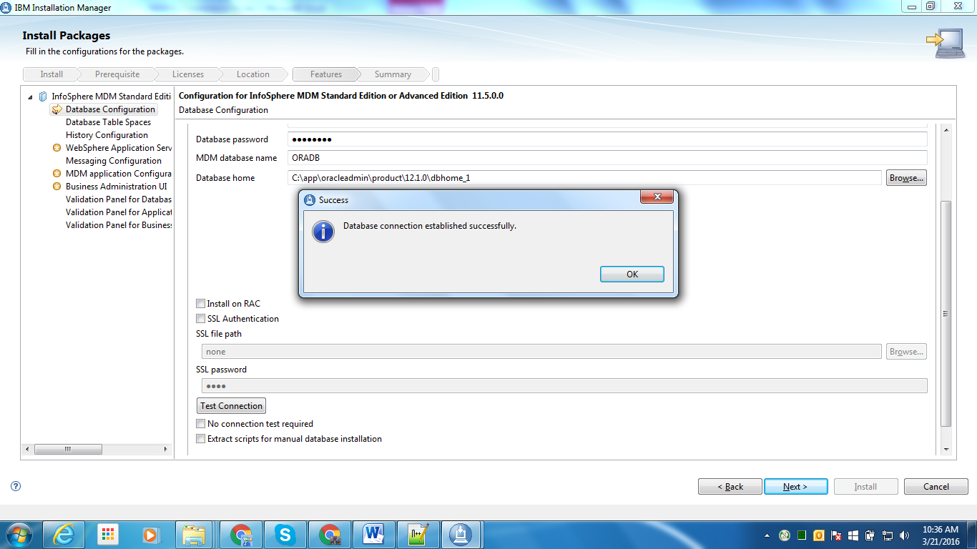

Click the **Test Connection** button and ensure the result is “Database connection established successfully”.

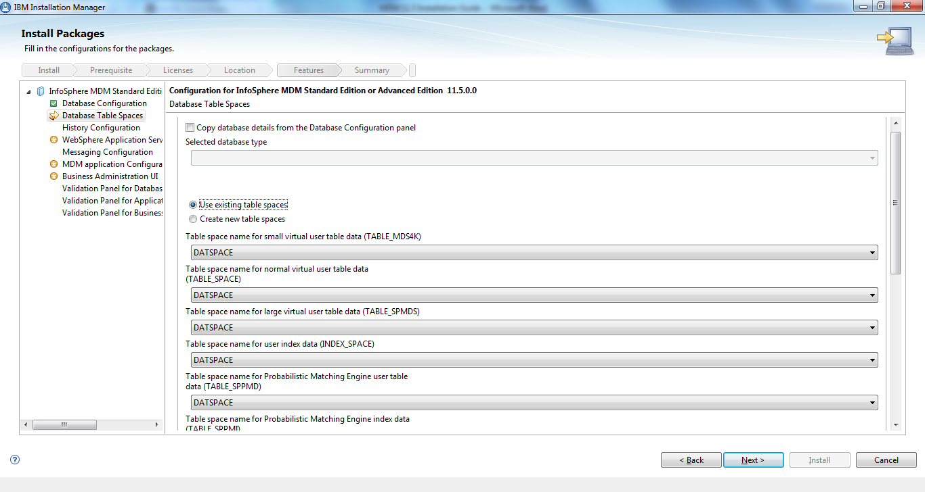

|  |  |
| --- | --- |
| Copy database details from database configuration panel | Checked |
| Selected Database type | Oracle |
| Use existing table spaces | Selected |
| Create new table spaces | Unselected |

Table Space Drop Downs

|  |  |
| --- | --- |
| TABLE\_SPACE | Use information provided by DBA |
| INDEX\_SPACE | Use information provided by DBA |
| TABLE\_SPPMD | Use information provided by DBA |
| TABLE\_SPPMI | Use information provided by DBA |
| LONG\_SPACE | Use information provided by DBA |
| TABLE\_MDSSM | Use information provided by DBA |
| TABLE\_SPMDS | Use information provided by DBA |

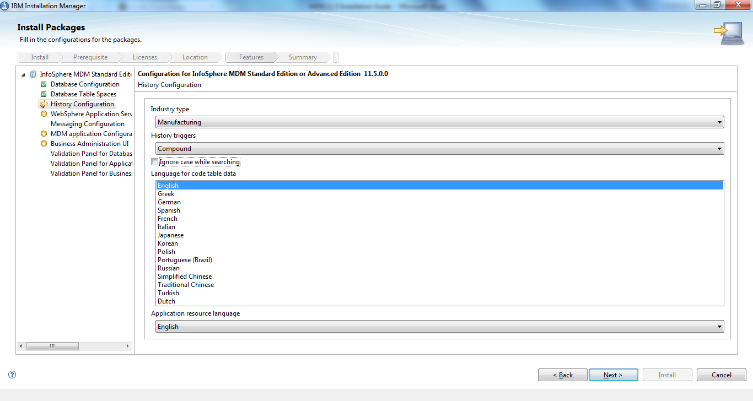

|  |  |
| --- | --- |
| Industry Type | Banking |
| Triggers | Compound |
| Ignore case while searching | unchecked |
| Language for code table data | English |
| Application resource language | English |

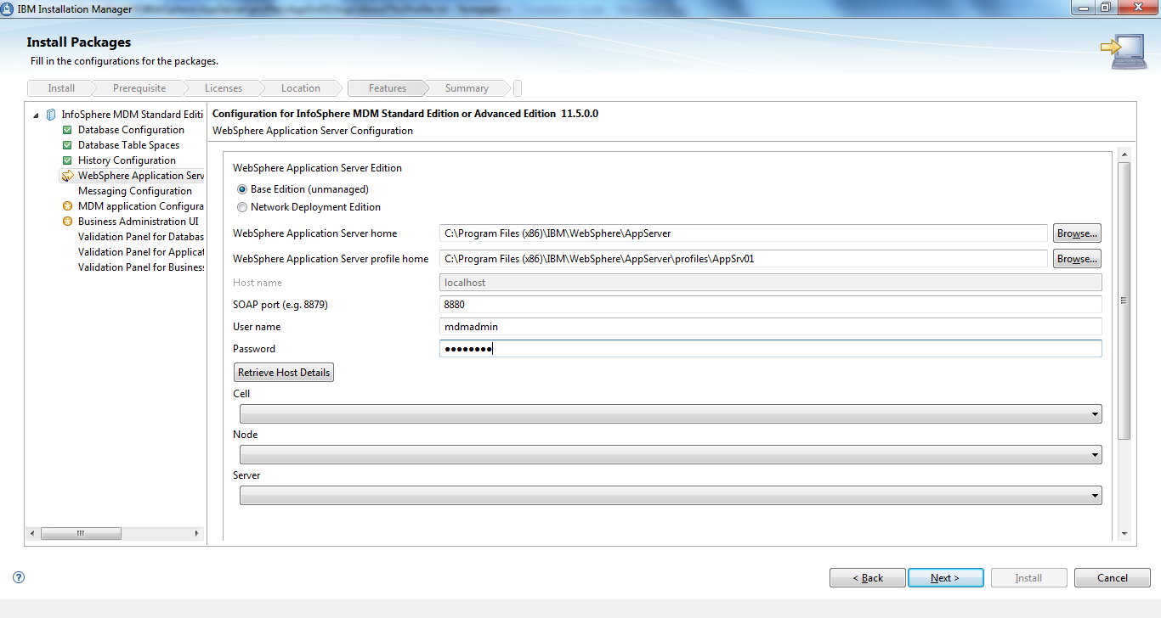

For WebSphere Application Configuration, select **Base Edition (unmanaged)** and fill in the following fields:

|  |  |
| --- | --- |
| WebSphere Application Server Home: | **<WAS\_HOME>** |
| WebSphere Application Server Profile Home: | **<WAS\_HOME>**\profiles\MDMDev01 |
| SOAP Port: | 8880 |
| Username: | mdmadmin |
| Password: | mdmadmin |

Click on **Retrieve Host Details**, and then after it succeeds, click on **Verify MDM Instance on Server**.

On the next screen select IBM Websphere Default Messaging

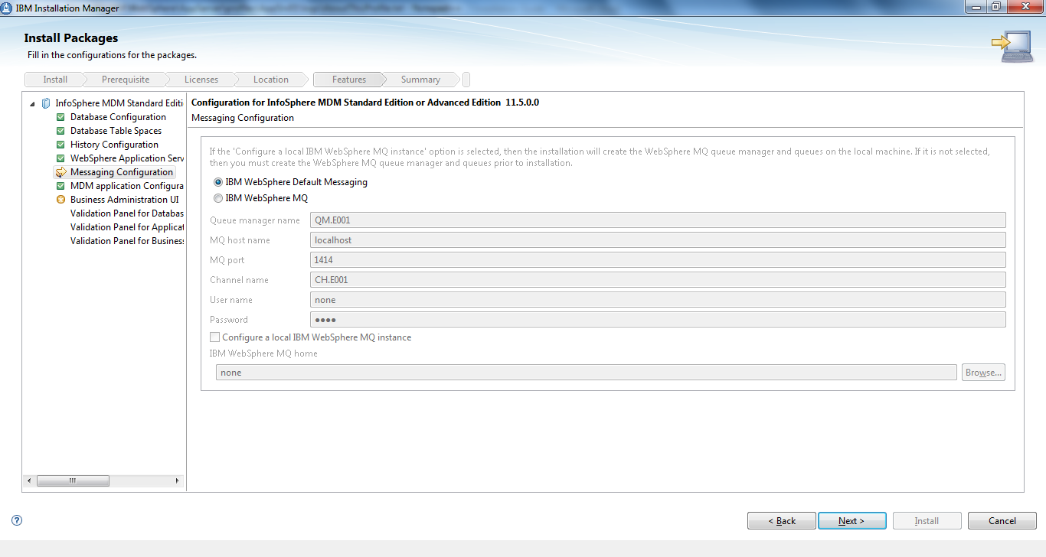

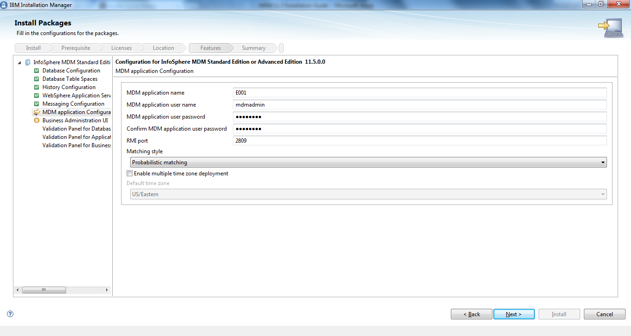

|  |  |
| --- | --- |
| Application Name | E001 |
| User “mdmadmin” password | mdmadmin |
| RMI Port | 2809 |
| Matching Style | Probabilistic |
| Multiple Time Zone Deployment | Disable |

This brings us to the first of two Verification Screens. The first verification screen is for MDM database verification.

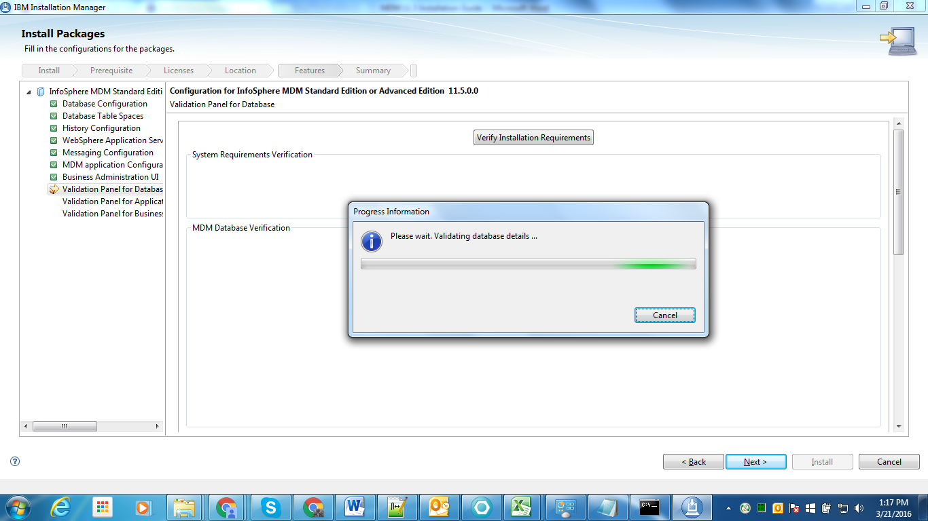

When the database verification has concluded it should contain two warnings one with regards to disk space and one with regards to Memory. These warnings can be ignored.

There should be no Error messages. Error messages indicate that something is incorrect and will cause the install to fail. These error messages must be rectified before the installation can continue.

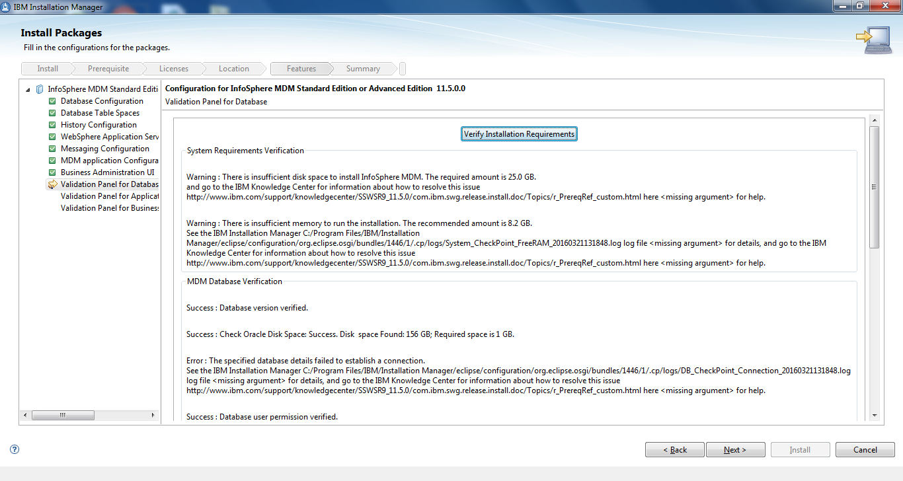

The above shows a Verification Error that must be resolved. The below shows a clean verification.

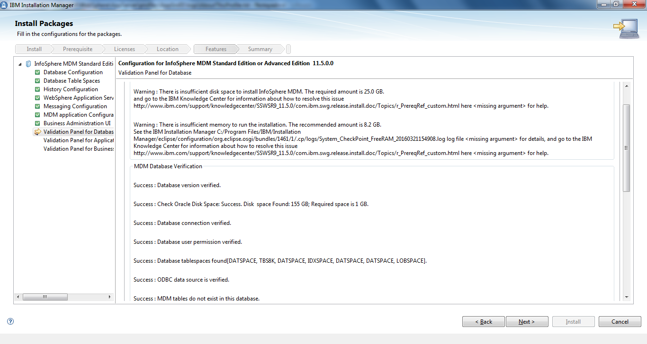

The next verification screen is for the application verification. Again there should be no Error messages on the completed verification screen. The screen shot below shows a successful verification screen.

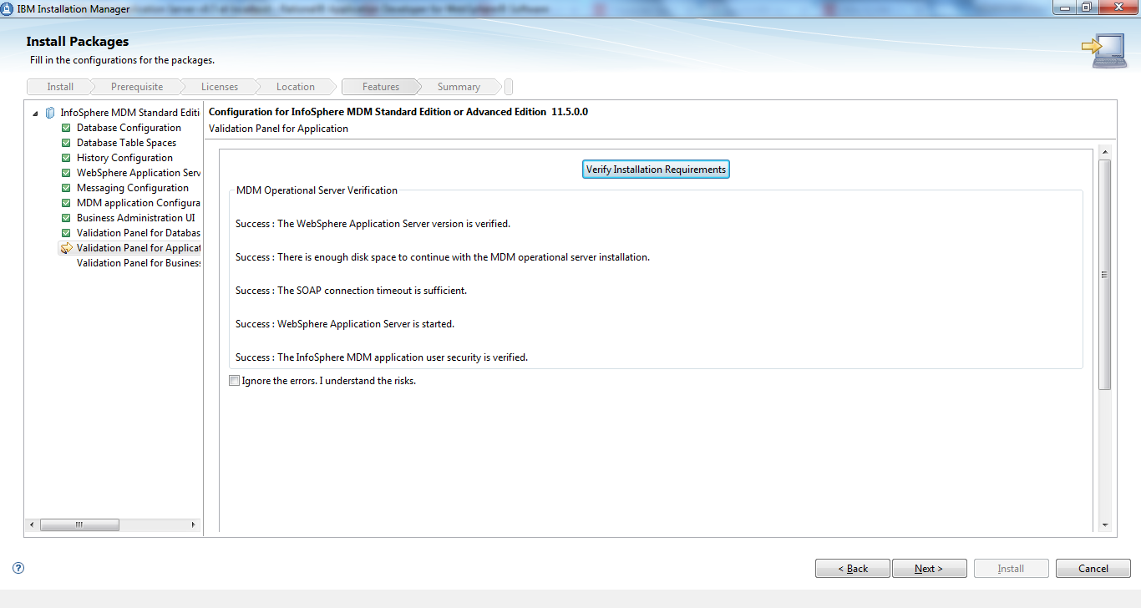

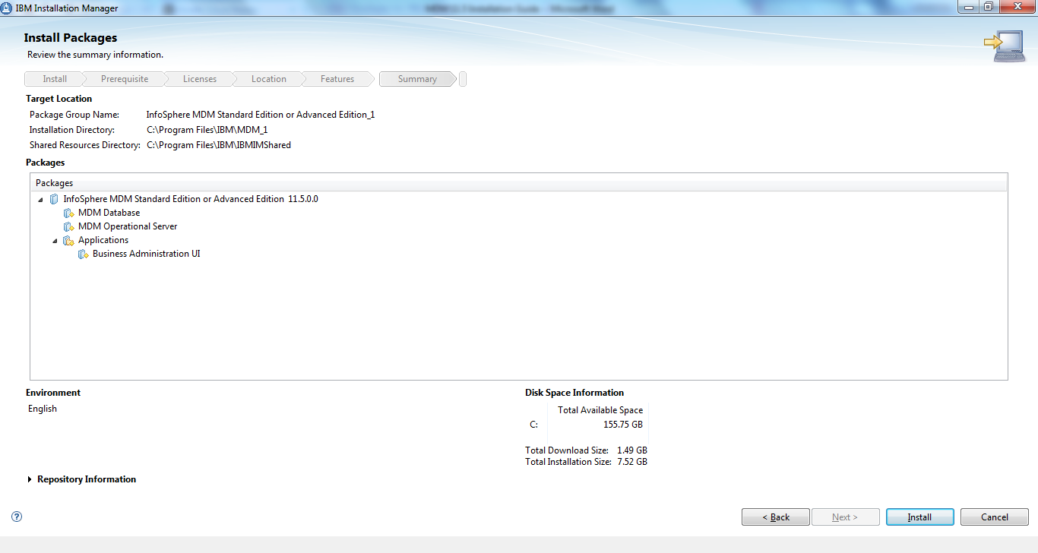

Click install.

The next screen should show a successful install.

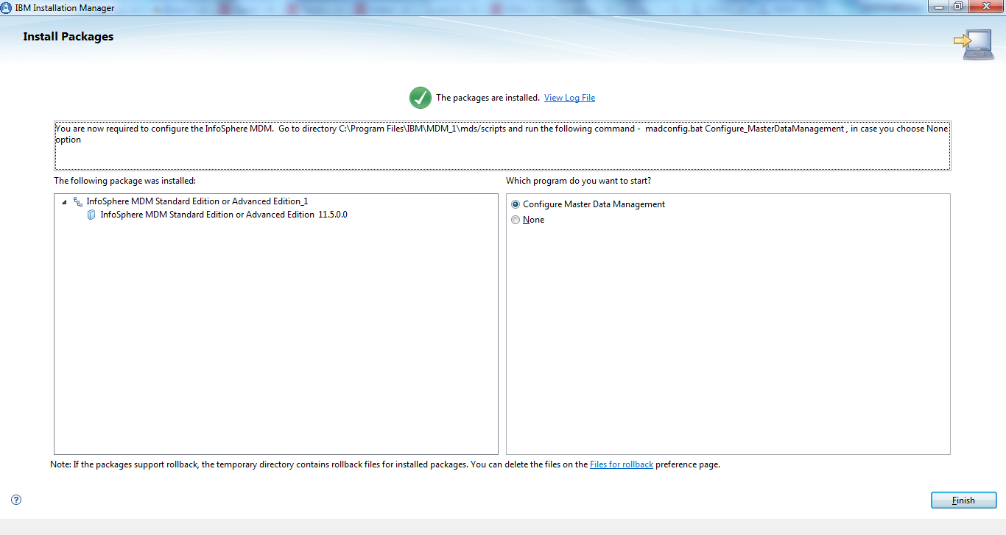

Click finish leaving the Configure Master Data Management radio button selected. Please take note that should you wish to invoke the configuration script separately it can be done so by selecting none here and running C:\IBM\MDM\mds\scripts\madconfig.bat Configure\_MasterDataManagement the recommended approach would be to do it as part of the install.

In the Configure MDM Script you will be asked for the following information:

|  |  |
| --- | --- |
| WebSphere Application Server profile password | mdmadmin |
| MDM Application password | mdmadmin |
| Database Password | Provided by the DBA |
| Perform Database connectivity test &  Application Server Status Check | yes |

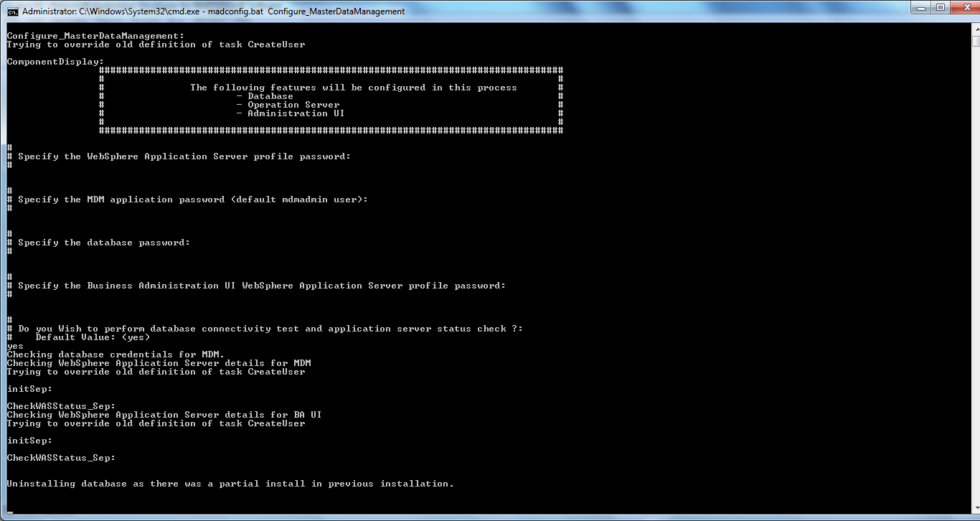

Upon completion we should see something like the screen shot below. It is common to see the IVT tests fail. Should this occur, a simple transaction can be run against the MDM application using SOAP UI to test the install or as stated in the screenshot the IVT tool itself can be executed.

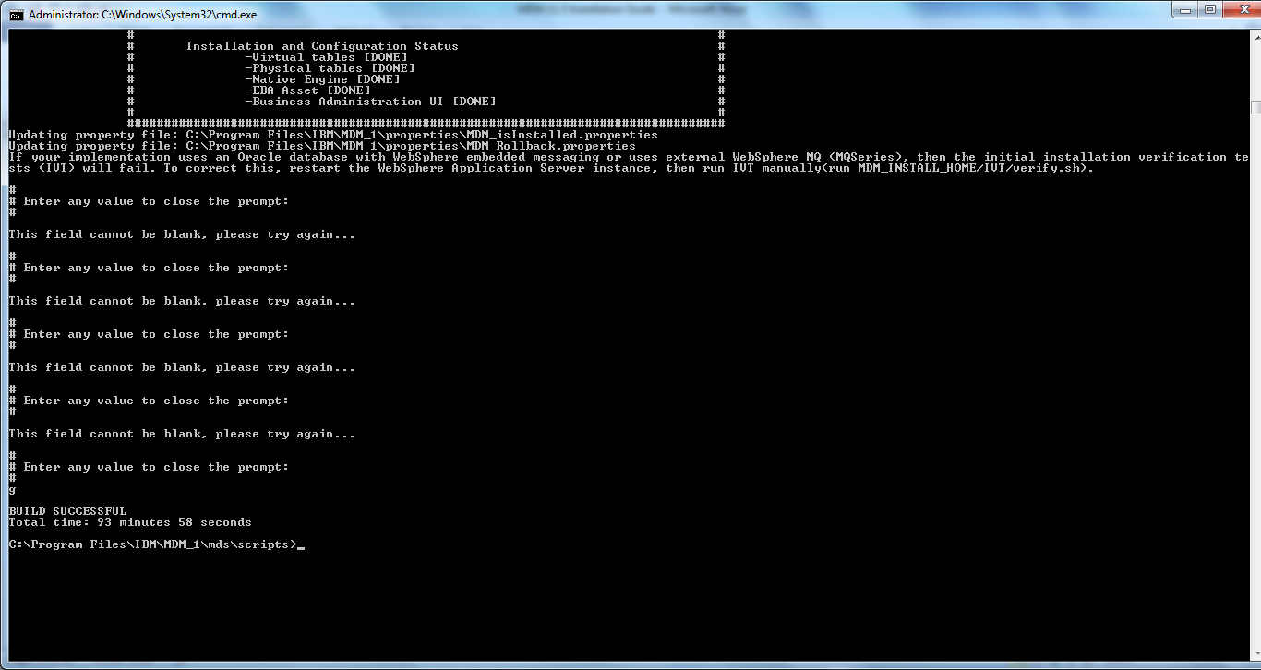

Should this install fail with an Oracle Database ORA-12514 connection refused exception, this is likely due to an issue with the installer.

The following tech note should be followed in this case - <https://www-01.ibm.com/support/docview.wss?uid=swg21982017>

This tech note basically states that you need to make the following changes to app.properties and db.properties in the <MDM\_INSTALL\_HOME>/properties folder.

You will likely find ...

* isRac=false
* dbName=<SID>
* dbService=<SID>

You will need to set them to ...

* isRac=true
* dbName=<SID>. eu.nag.net
* dbService=<SID>. eu.nag.net

## Install RAD with Workbench

Select RAD and MDM Workbench with the Installation Manager.

Select “IBM Rational Application Developer for WebSphere Software v8.5.5" and "IBM InfoSphere Master Data Management Workbench v11.5.0.3 ".

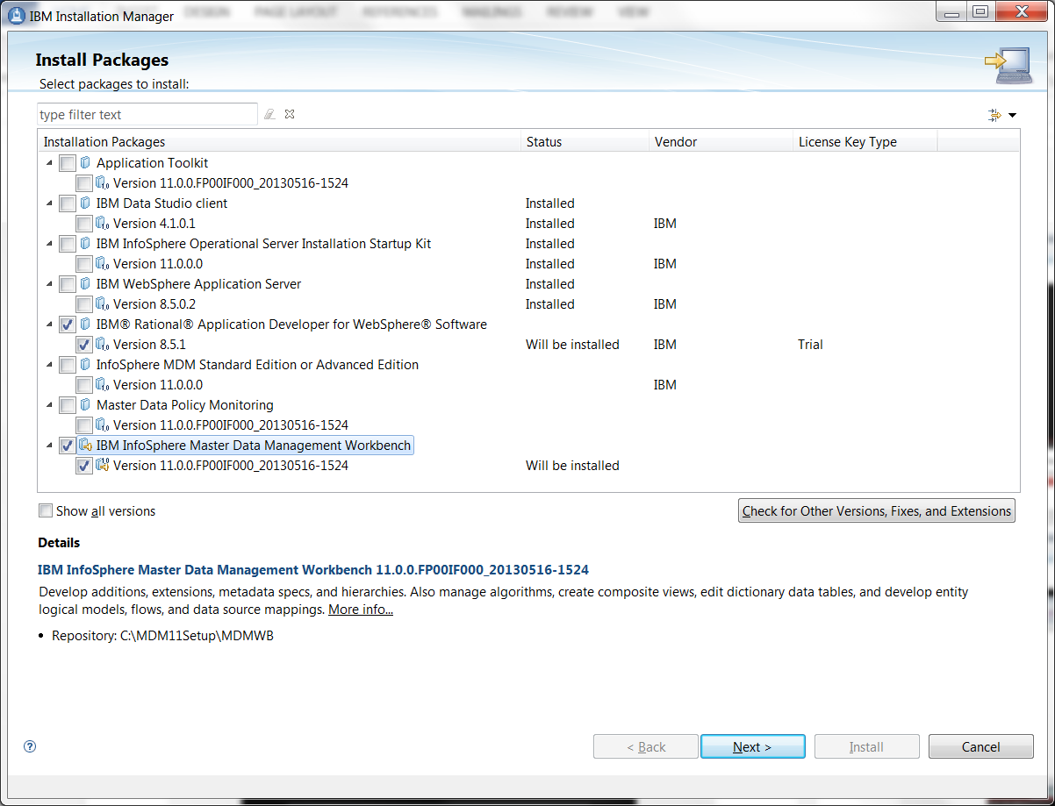

Select “Check for Other Versions, Fixes, and Extensions”.

Click “show all versions” then select RAD 9.5 and workbench again. Select next.

Use “C:\IBM\SDP” as RAD home and choose 64bit.

Select defaults for the rest of the settings to the end.

## RAD configuration

Start Rational Application Developer.

### Enable Capabilities

Navigate to “Window” 🡪 “Preferences” 🡪 “General” 🡪 “Capabilities”**,** then click “Enable All” and “Apply”.

### Modify WebSphere Server Runtime Environment

Navigate to “Window” 🡪 “Preferences” 🡪 “Server” 🡪 “Runtime Environments”**,** then select “WebSphere Application Server v8.5” and “Edit”. (If WebSphere Application Server v8.5 does not exist Click Add)

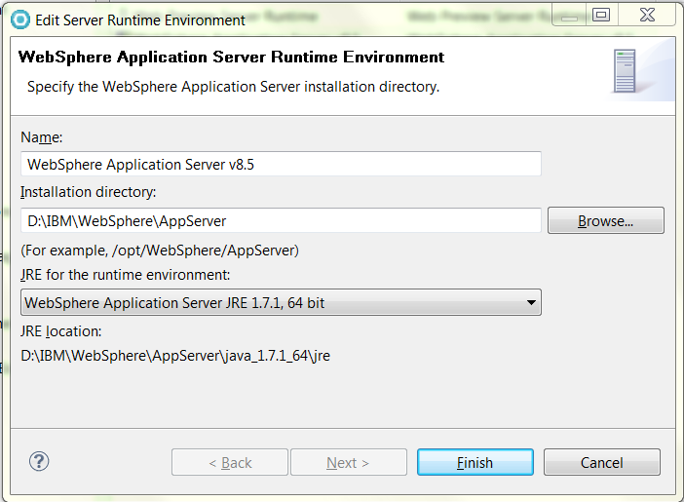

Ensure that the JRE is set to WebSphere Application Server JRE 1.7.1, 64 bit.

### Configure MDM Application Path

Navigate to “Window” 🡪 “Preferences” 🡪 “MDM Data Management” 🡪 “Application Path”**,** click “Change” button then select “InfoSphere MDM Standard Edition or Advanced Edition, Version 11.5.0.0” if it is not (at the bottom, it says “C:\IBM\MDM”). Do not Select the Workbench version

### cid:_1_06B7E36406B7BA300057B77F80258025

### Workspace preparation

Launch RAD as administrator then start WAS.

A test project is needed to make sure the workspace is ready for MDM development.

Press Crtl-N, then go to “Master Data Management” 🡪 “Development Project”.

**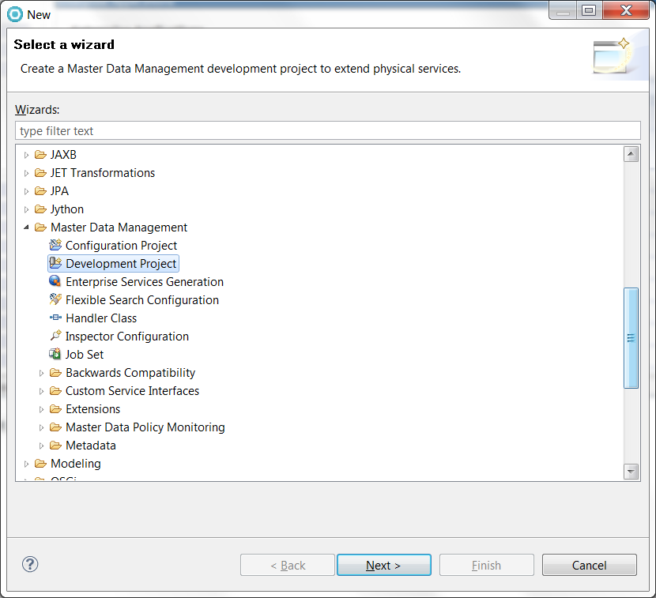**

Type “test” for “Project name” and “Base Java package name”.

**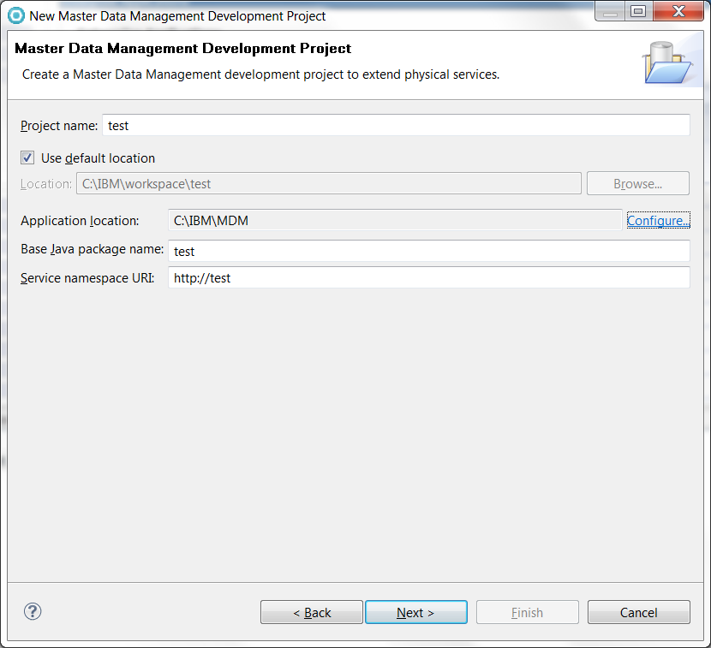**

Use “test” at “Identifier” field, use the developer database schema as “Database schema name”, then click “Finish” button then a test project will be created.

**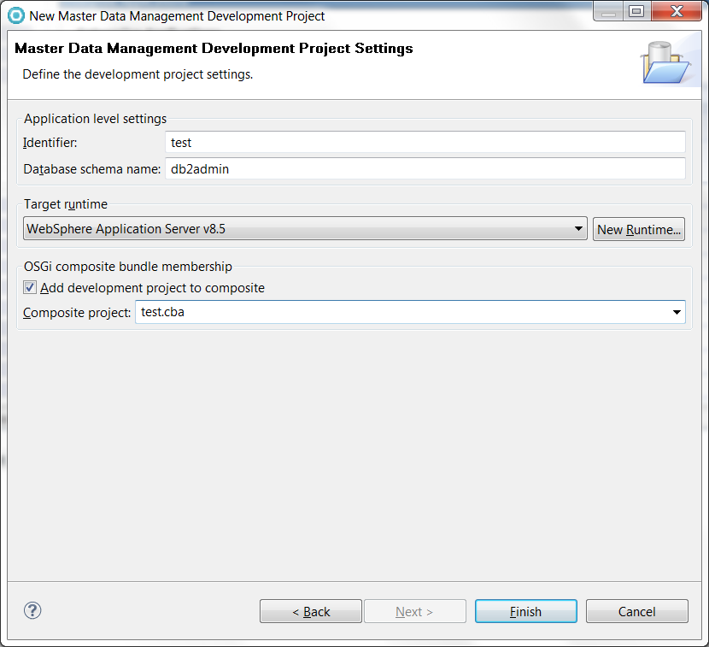**

Go to “Model” tab.

**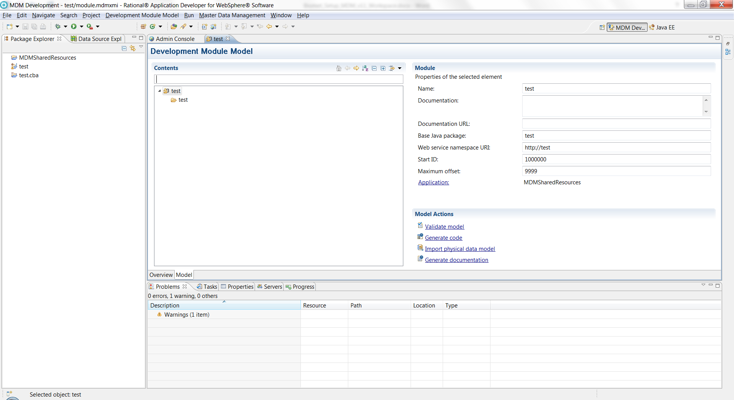**Right click the down below “test” then “New” 🡪 “Entity Type”.

Ctrl-S to save this project then click “Validate model” to make sure it is valid.

**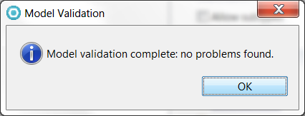**

Click “Generate code” to generate associated code files.

**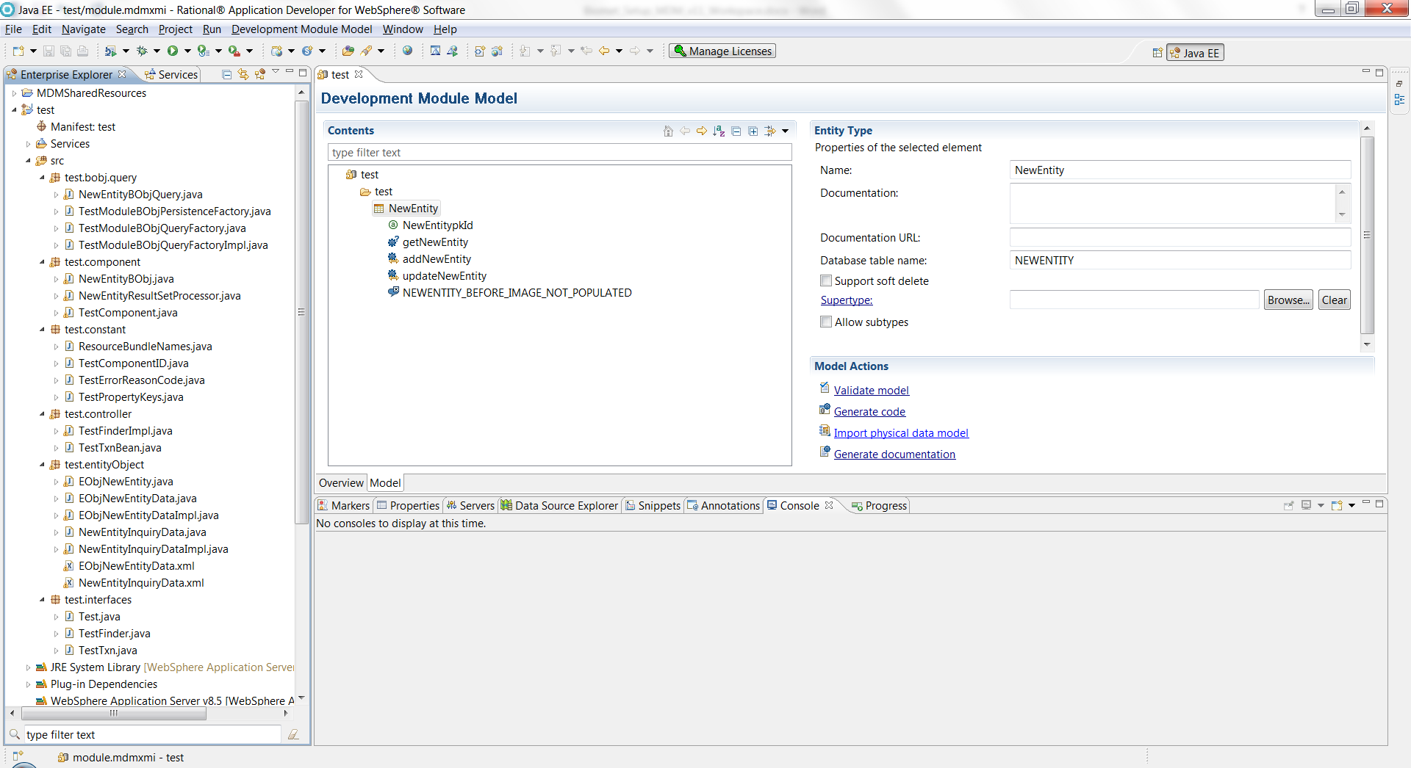**If there are no error messages, the test has been done successfully.

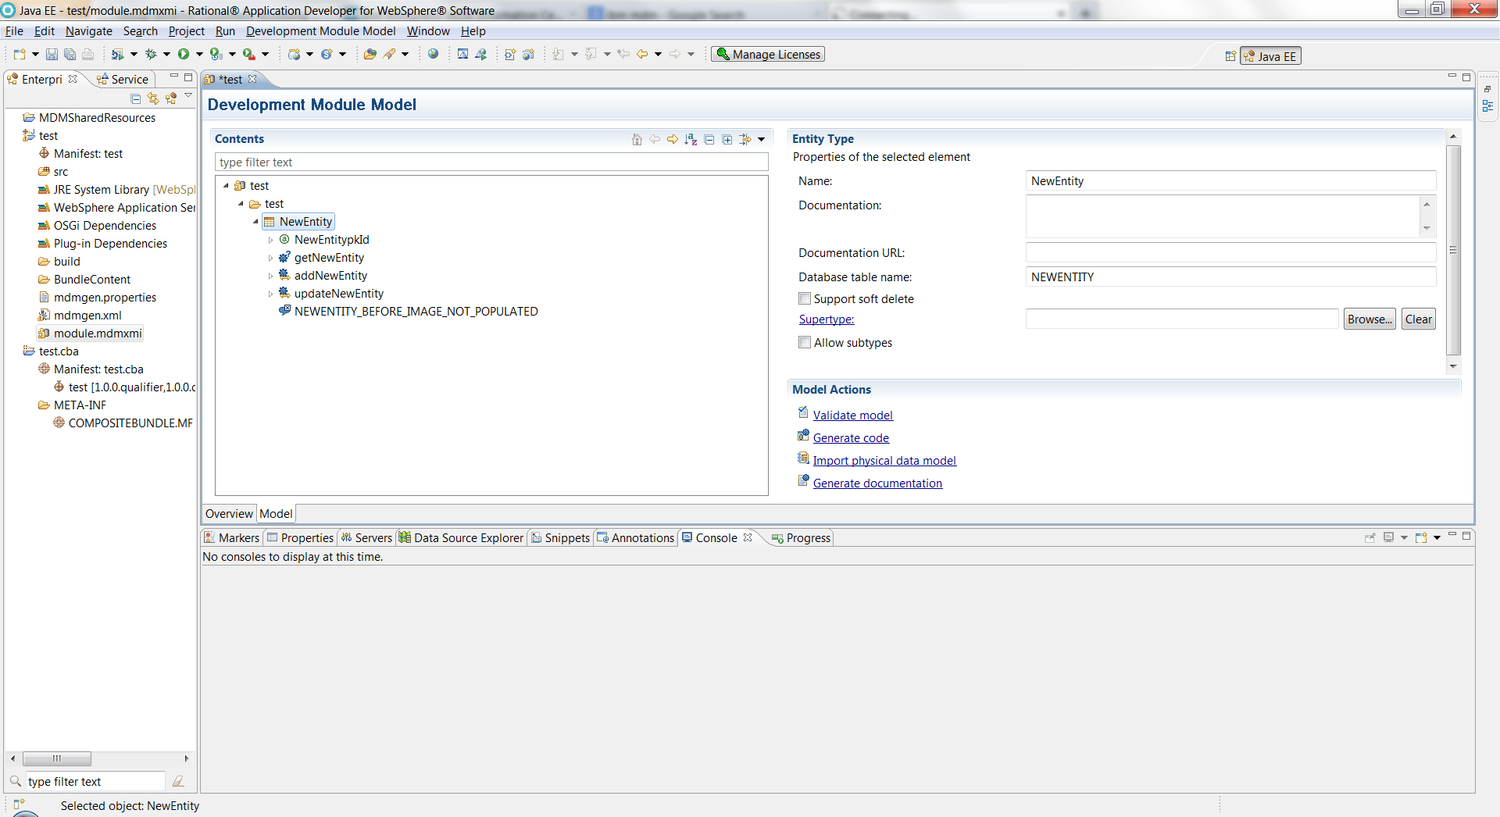

Select all items in “Enterprise Explorer”, then right click for “Delete”, and check “Delete project contents on disk (cannot be undone)”.

At the end, there should be nothing in “Enterprise Explorer”

### Add RAD Activation Key

Open the IBM Installation Manager

Select Manage Licenses

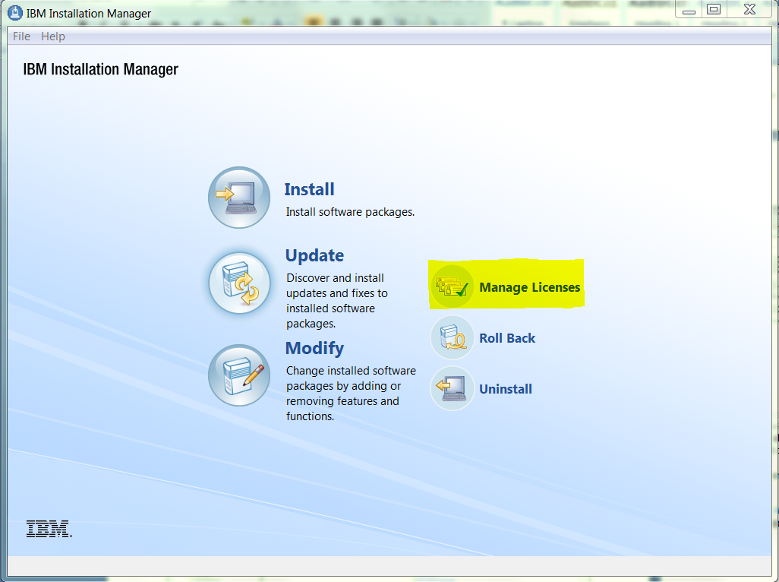

Select IBM Software Delivery Platform > IBM Rational Application Developer for WebSphere Software

Then select Import product Activation Kit and select Next

